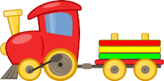
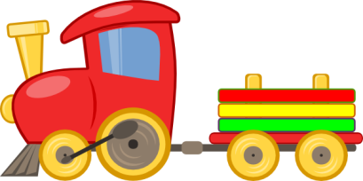

THANK YOU FOR YOUR INTEREST IN OUR PRESCHOOL. SHOULD YOU DECIDE TO ENROLL YOUR CHILD INTO K.I.D.S.,

THE FOLLOWING IS A LIST OF SKILLS THAT YOUR CHILD SHOULD HAVE MASTERED BEFORE THEY ENTER KINDERGARTEN:

Tells first and last name
Writes at least their first name correctly
Identifies letters in at least their first name
Identifies basic colors
Recognizes basic shapes
Say the ABCs
Identifies most letters in alphabet
Can identify some beginning sounds to letters in the alphabet
Identifies words that rhyme
Counts to at least 20
Counts objects to 10
Recognizes some numbers in random order

THE FOLLOWING IS A LIST OF SKILLS THAT YOUR CHILD WILL BE WORKING ON BEFORE ENTERING KINDERGARTEN

Identifies individual words in a sentence
Identifies syllables in simple words
Identifies simple sight words (I, a, my, we, go, like, in, the, little, see, etc.)
Identifies sight words in a sentence
Counts using 1:1 math concept

And learning how to interact socially with children and adults that they interact with on a regular basis along with LOTS and LOTS of FUN!

